Alexandria University,

Faculty of Engineering,

Computer and Systems Engineering Dept.

CS222: System programming

|  |
| --- |
|  |

Lab (1) Report

Name:

Abdel-Fatah Mohamed Abdel-Fatah. (24)

Content:

1. Simulator.
2. PROGRAMS.

1. Set ALPHA equal to the integer portion of BETA / GAMMA.
2. Set ALPHA equal to 4 * BETA + 3 * GAMMA
3. Clear a 100-byte string to all blanks
4. SET elements of a 100-word array to 0
5. Read a string from device F3, calculate its length and store it in register A
6. Read a two-digit number from device F3, convert this string to a number and store the number in register A

***Simulator:

(before all examples).

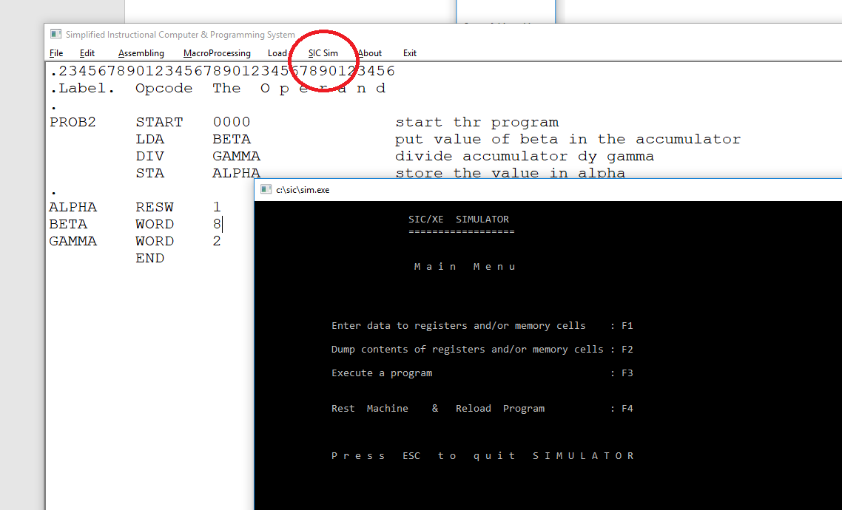

* 1. Execute a program (F3).

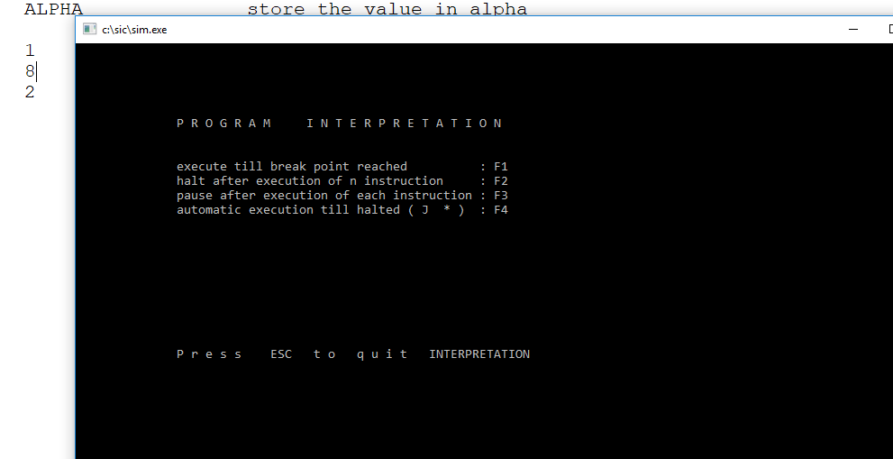

b. Automatic execution till halted (F4):

And press any button to execute instruction till the end.

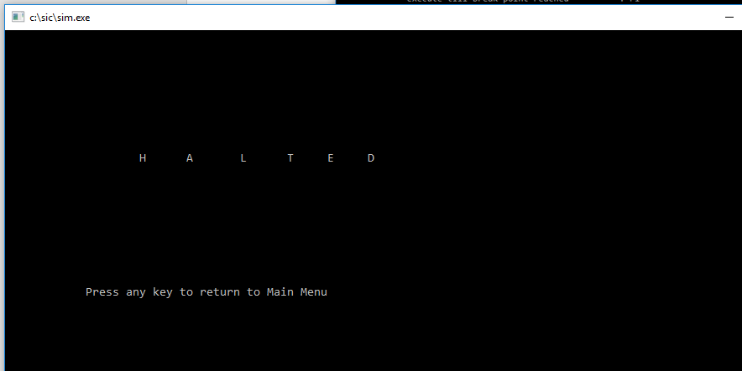

C. Dump contents of registers and/or memory cells (F2):

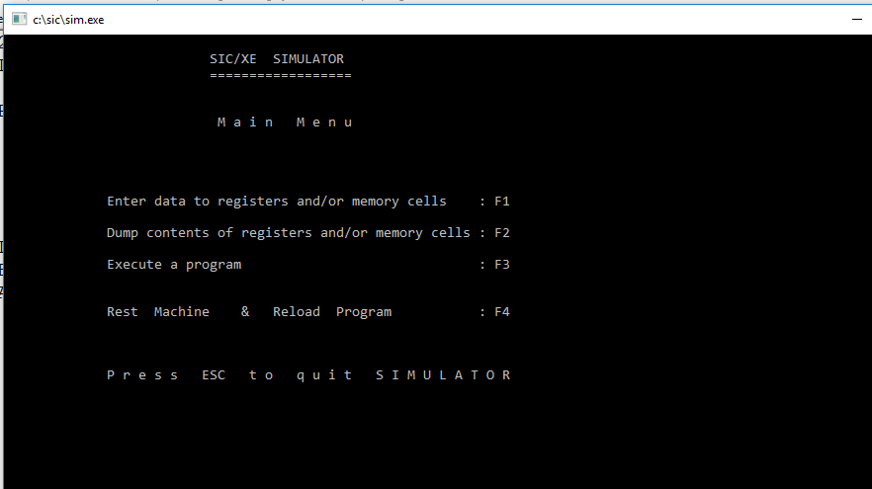

D. Contents of Reg. and Memory (F3):

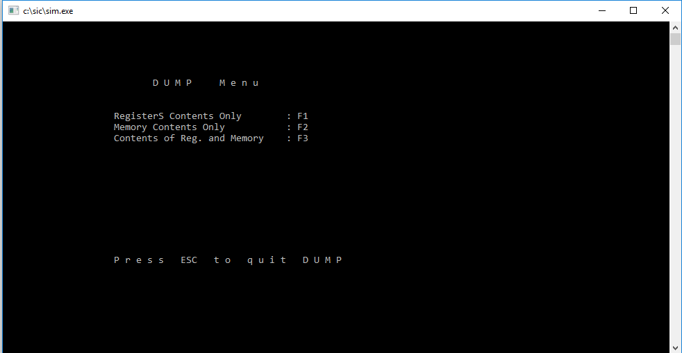

1. Set ALPHA equal to the integer portion of BETA / GAMMA:
2. Code:

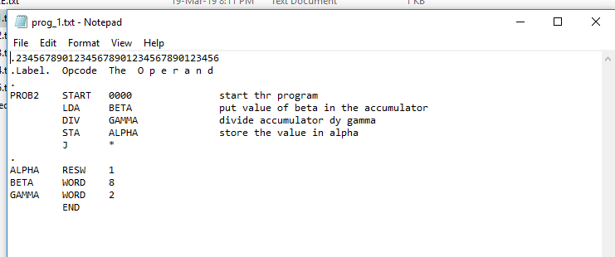

1. Assembling:

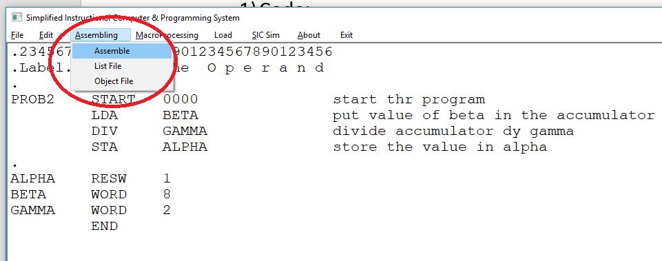

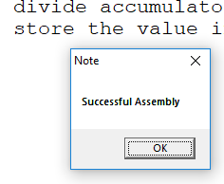

1. Sample run:

Beta = 8 gamma = 2 then. alpha = 4

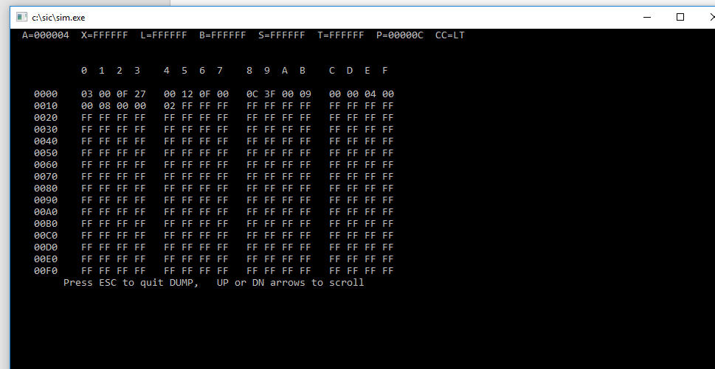

Beta = 25 gamma = 5 then alpha = 5

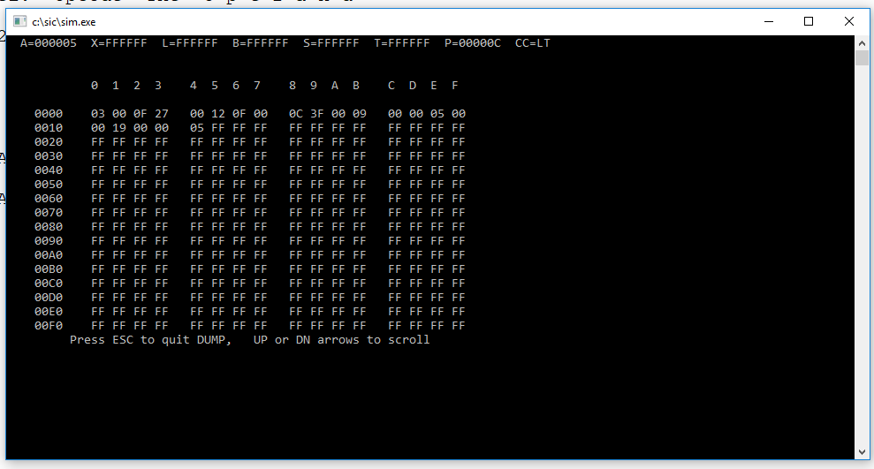

1. Set ALPHA equal to 4 * BETA + 3 * GAMMA

1) Code:

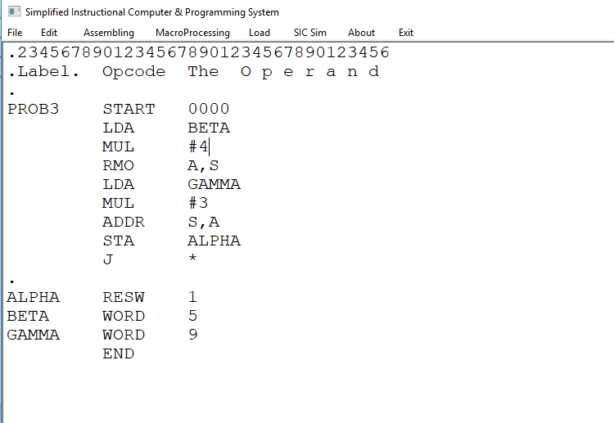

1. Assembling:

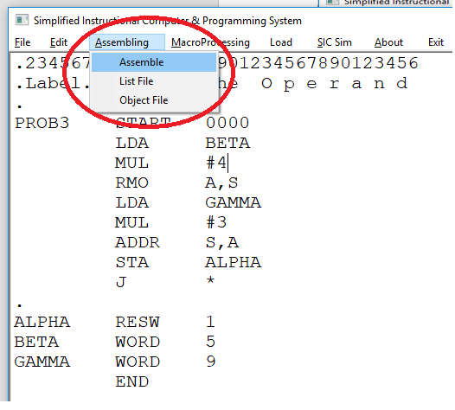



1. Sample run:

Beta = 5 gamma = 9 then. alpha = 47

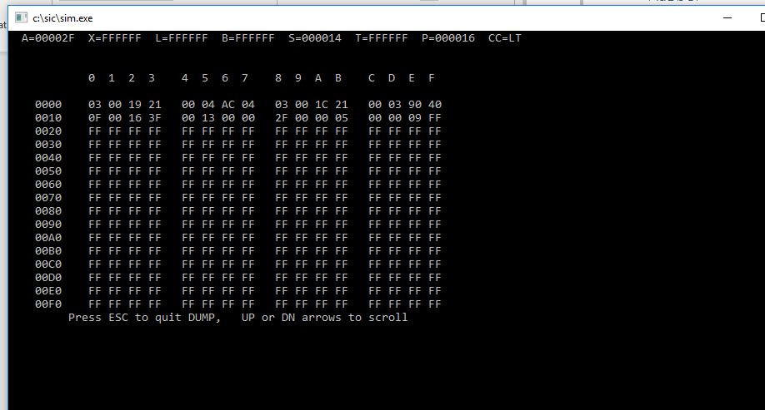

Beta = 25 gamma = 5 then alpha = 5

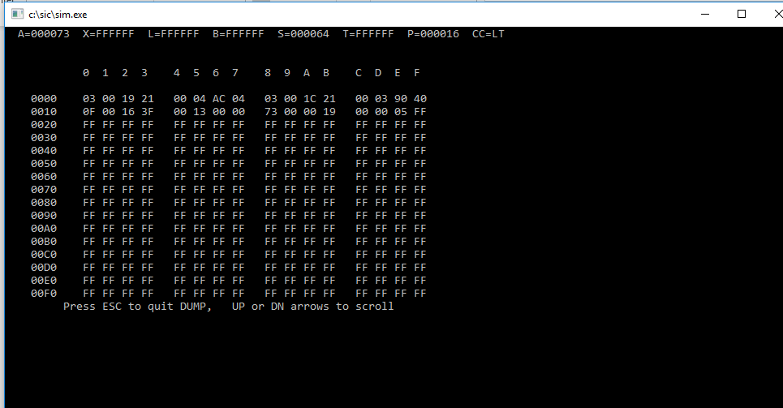

1. Clear a 100-byte string to all blanks:
2. Code:

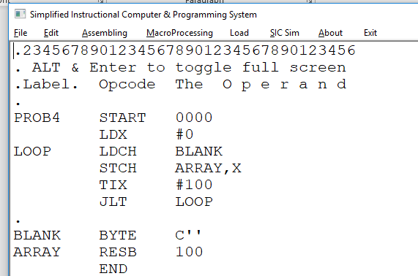

1. Assembling:

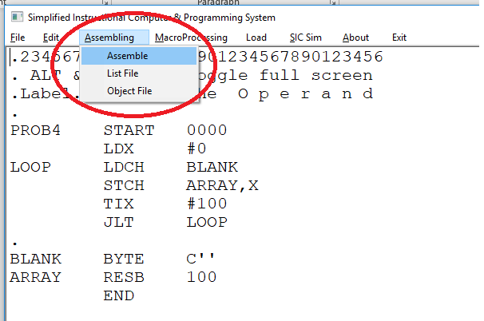



1. Sample run:

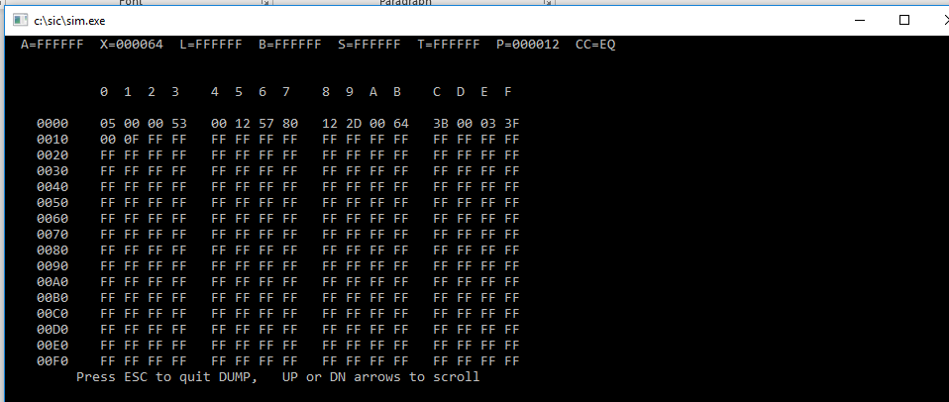

1. SET elements of a 100-word array to 0:
2. Code:

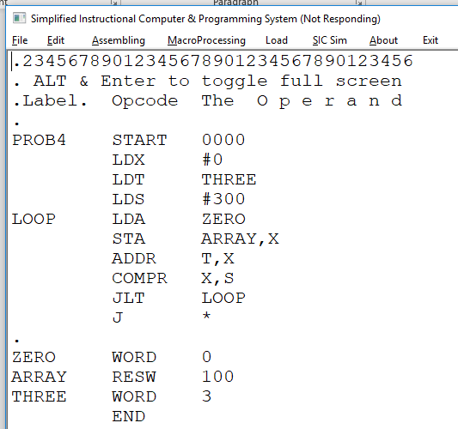

1. Assembling:

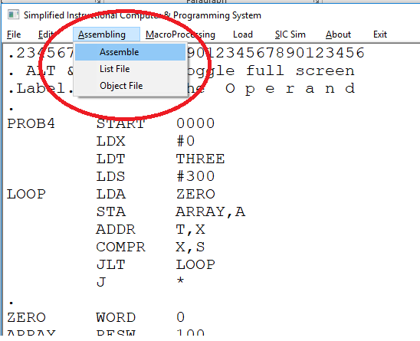



1. Sample run:

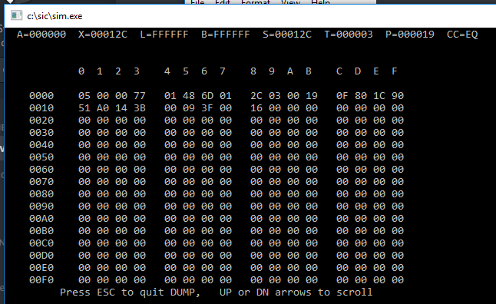

1. Set ALPHA equal to the integer portion of BETA / GAMMA:
2. Code:

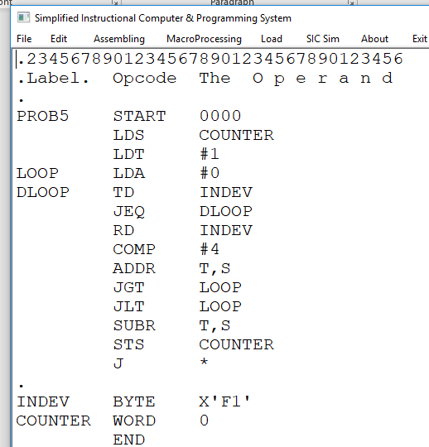

1. Device:

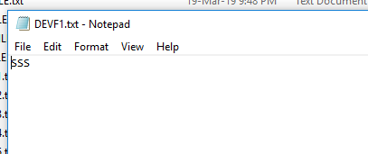

1. Sample run:

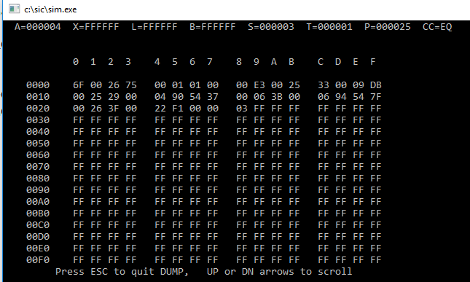

1. Read a two-digit number from device F3, convert this string to a number and store the number in register A:
2. Code:



1. Device:

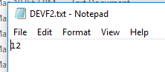

1. Sample run:

